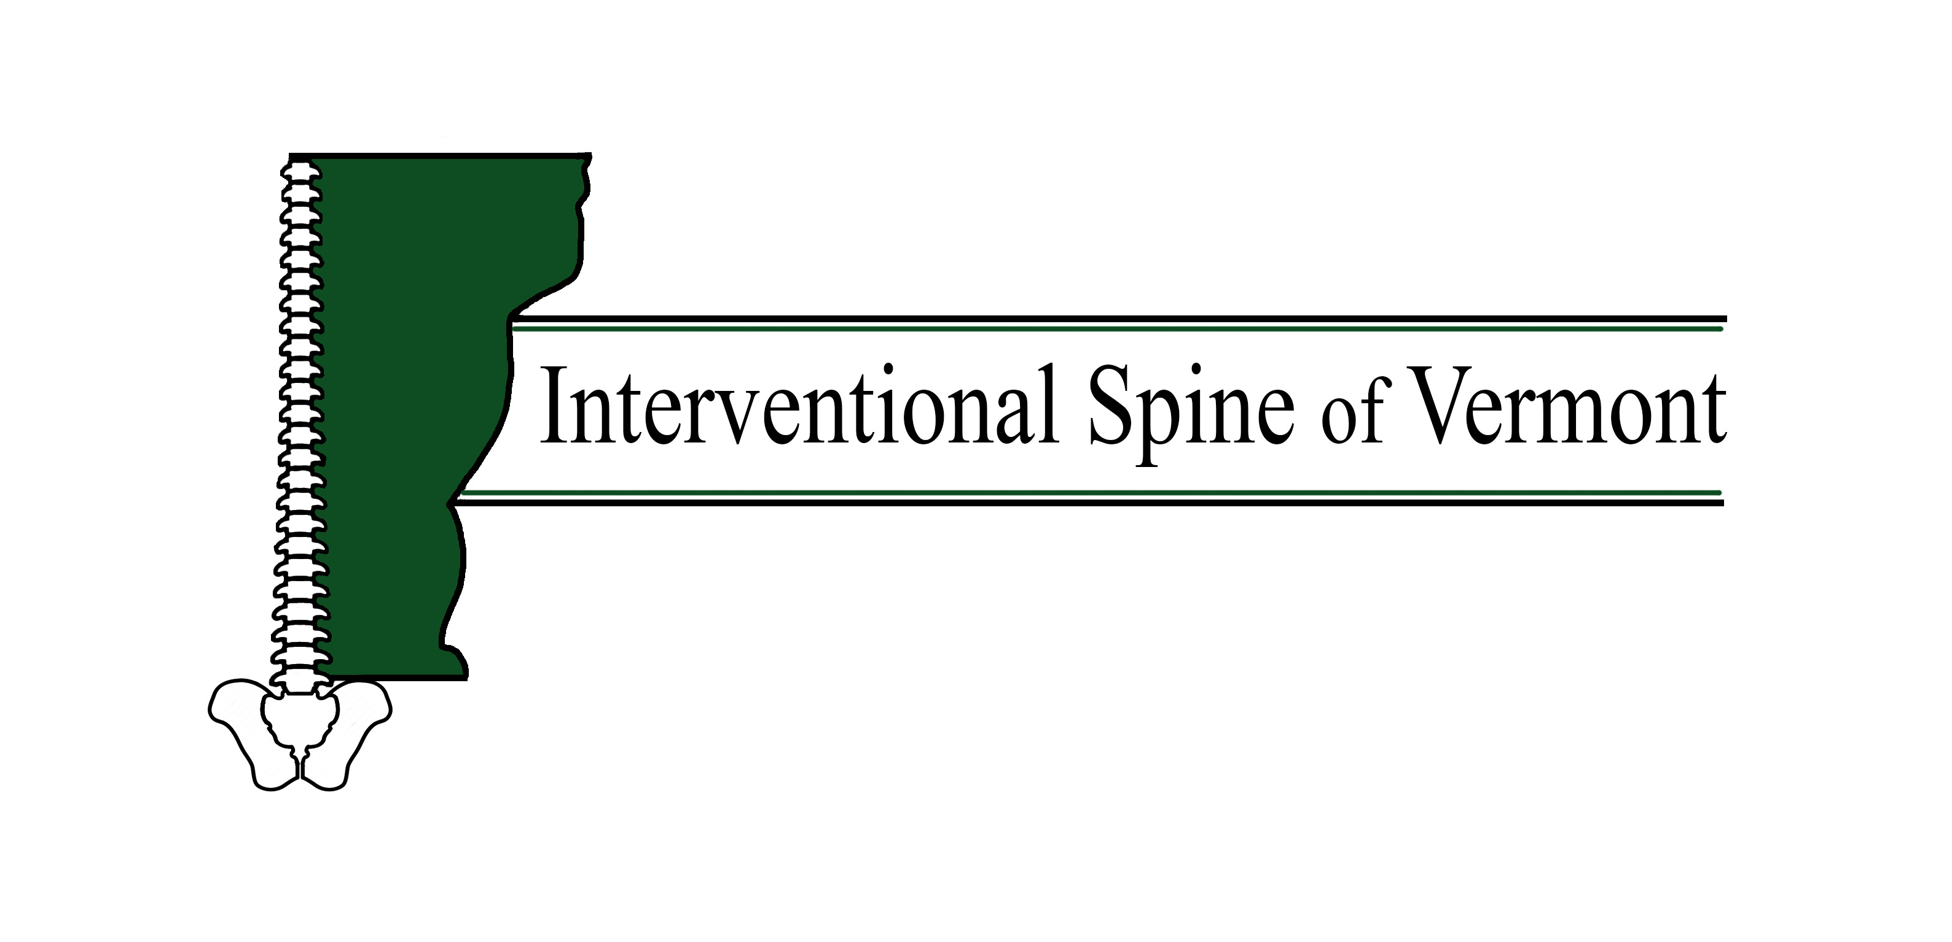
Medial Branch Blocks
What is it? | There are joints in the spine which can, like any joint in our body, show signs of wear and tear and as a result cause pain. The small nerves that innervate these joints are commonly referred to as “medial branches.” Medial branch radiofrequency ablation are aimed at creating a lesion at these nerves which stops their transmission of pain for an average of 9 months. Medial branch blocks diagnostic tests must be done twice prior to ablation if billing insurance. cedure, you do not need the diagnostic blocks.
Why is it performed? | Radiofrequency Denervation or ablation helps reduce pain by using a heated probe (a very thin wire) to destroy the medial branches (the nerves that transmit pain in the facet joints). These nerves can regrow, so the procedure has to be repeated once a year typicaly (but the diagnostic blocks do not)
How is it done? | When you are in the procedure room, you will be asked to lie on your stomach on an x-ray table. A small needle is used to inject a local anesthetic (numbing medication) in the skin, this may feel like a pinching or burning sensation. This will be done at the same levels at which your diagnostic blocks were done. At that point, a small needle will be inserted through the numb portion of skin towards the area of interest injured nerve with the help of the x-ray machine. When satisfactory placement of the needle is confirmed, a short test will be performed in which you may feel some “thumping” (but this is not typically painful). Once this test is done and needle placement is satisfactory, more numbing medicine is placed. Once the area is numb, the lesion is performed. IF you feel any pain, please let your physician know as there are multiple ways to make this a pleasant experience. Most people feel either nothing or slight pressure while having the ablation done. The needle will be removed and a bandaid will be applied.  Youu should start experiencing relief 4-6 weeks after the procedure, lasting anywhere between 6 months and 2 years.
How long will it take? | Depends, usually 30 minutes
What do I do if I am ill or have to cancel? | Please call the office 24 hours in advance if you are unable to keep your appointment. 802-404-2004 We charge $50 for no shows.
When should I arrive? | Please arrive 15 minutes prior to your appointment.
Can I drive for the procedure? | In general, no. If you cannot bring a driver you will have to call us ahead of time so the provider is aware and can monitor you afterwards
Can I have sedation for the procedure? | You can if there are no contraindications. In this case you should arrive 30 minutes prior to your appointment time and not eat anything that day. You can have clear liquids (such as BLACK coffee, water, gatorade and anything you can see through) up to 2 hours prior to the procedure. You will need a driver to receive sedation.
Can I take my medications? | Please take all your medication except for blood thinners and supplements. Also please stop NSAIDs (including but not limited to ibuprofen, advil, motrin, naproxen) 24 hours prior to your injection
Should I stop my aspirin? | If you take more than 81 mg of aspirin a day, you must stop taking it 5 days prior to your procedure (examples of ASPIRIN‐containing products include but are not limited to: EXCEDRIN, FIORINAL, AND ALKA SELTZER, etc). You can continue aspirin 81 mg if you take it for stroke or heart attack prevention.
Will I receive a pre‐procedure phone call? | You will receive an automated phone call or text (if enabled) from our office 24‐48 hours prior to your procedure. We must have a verbal confirmation from you 24‐48 hours prior to your procedure. Failure to return our call could result in your procedure being rescheduled.
What are side effects of the ablation? | You could experience increased pain at the injection sites that can last for 2-3 days. In addition, you may experience a sunburn sensation that could last weeks (more likely in the neck or thorax)
Risks of this procedure include, but are not limited to: | Pain at the injection site for 2-3 days (ice can help)  Reaction to the local anesthetic Please let us know if you have ever had a reaction  Side effects from steroids as above.  Tell us before the procedure if taking blood thinners, have a blood disease that affects clotting, have a bowel obstruction and or have an uncontrolled infection.  Bleeding in the area of the injection due to damage to blood vessels.  Possible, but unlikely side effects are:  -- infection  -- bleeding  -- nerve damage  -- worsened pain  -- no improvement  -- stroke  -- death

