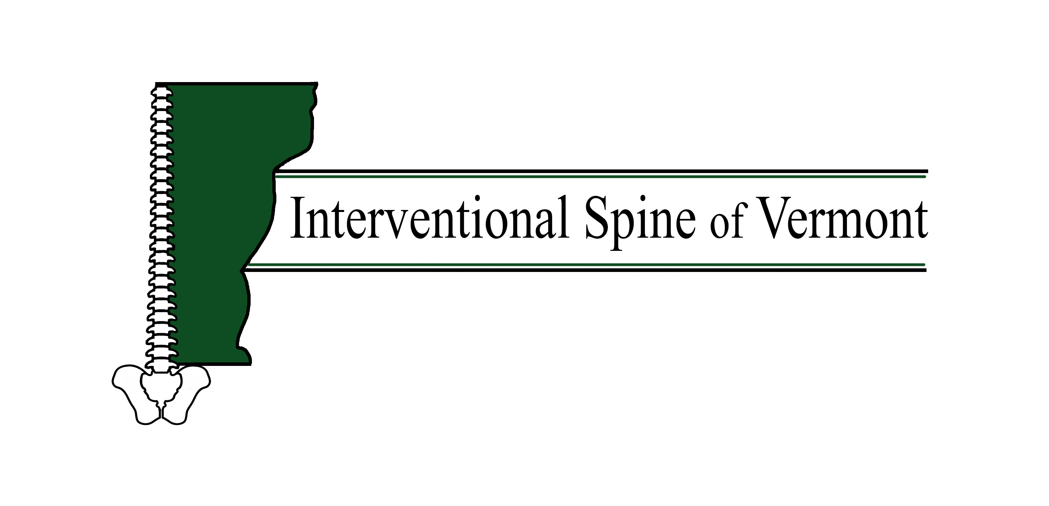
Epidural steroid injection
What is it? | An epidural steroid injection is an injection performed on the spine. An x-ray machine assists the healthcare provider in locating the nerve roots that are thought to be irritated and contributing to your pain.
Why is it performed? | This procedure is performed on patients with pain in their back, their legs, their neck or arms most typically. There are many other indications (can also be done in the thoracic spine for instance). The goal of the procedure is to place antiinflammatory medication (steroid) in the epidural space which helps alleviate inflammation and decrease production of neuroinflammatory hormones (chemicals that transmit pain). Typically the relief from the injection does not start until 7-10 days after the procedure as the steroid takes some time to change the chemical environment in the spine.
How is it done? | When you are in the procedure room, you will be asked to lie on your stomach on an x-ray table. A small needle is used to inject a local anesthetic (numbing medication) in the skin, this may feel like a pinching or burning sensation. At that point, a small needle will be inserted through the numb portion of skin towards the area of interest injured nerve with the help of the x-ray machine. Dye may be injected to confirm correct location of the needle in the epidural space. When satisfactory placement of the needle is confirmed, steroid medication with or without some sterile saline will be injected. The needle will be removed and a bandaid will be applied.
How long will it take? | Depends, usually 10-15 minutes
What do I do if I am ill or have to cancel? | Please call the office 24 hours in advance if you are unable to keep your appointment. 802-404-2004 We charge $50 for no shows.
When should I arrive? | Please arrive 15 minutes prior to your appointment.
Can I drive for the procedure? | In general, no. If you cannot bring a driver you will have to call us ahead of time so the provider is aware and can monitor you afterwards
Can I have sedation for the procedure? | You can if there are no contraindications. In this case you should arrive 30 minutes prior to your appointment time and not eat anything that day. You can have clear liquids (such as BLACK coffee, water, gatorade and anything you can see through) up to 2 hours prior to the procedure. You will need a driver to receive sedation.
Can I take my medications? | Please take all your medication except for blood thinners and supplements. Also please stop NSAIDs (including but not limited to ibuprofen, advil, motrin, naproxen) 24 hours prior to your injection
Should I stop my aspirin? | If you take more than 81 mg of aspirin a day, you must stop taking it 5 days prior to your procedure (examples of ASPIRIN‐containing products include but are not limited to: EXCEDRIN, FIORINAL, AND ALKA SELTZER, etc). You can continue aspirin 81 mg if you take it for stroke or heart attack prevention.
Will I receive a pre‐procedure phone call? | You will receive an automated phone call or text (if enabled) from our office 24‐48 hours prior to your procedure. We must have a verbal confirmation from you 24‐48 hours prior to your procedure. Failure to return our call could result in your procedure being rescheduled.
What are side effects of the steriods? | Flushing, higher sugar levels, higher blood pressure, mood swings, problems sleeping, and they can lower your bone density among many side effects
Risks of this procedure include, but are not limited to: | Pain at the injection site for 2-3 days (ice can help)  Reaction to the local anesthetic or dye. Please let us know if you have ever had a reaction to either  Side effects from steroids as above.  Tell us before the procedure if taking blood thinners, have a blood disease that affects clotting, have a bowel obstruction and or have an uncontrolled infection.  Bleeding in the area of the injection due to damage to blood vessels.  Possible, but unlikely side effects are:  -- infection  -- bleeding  -- nerve damage  -- worsened pain  -- no improvement  -- stroke  -- death

